Horticulture Leaf Identification Walk

Take a walk around your neighborhood or in your own yard.
Record the following information about the plants that you have found. Use the graphics below to help you correctly identify key characteristics about your plant.

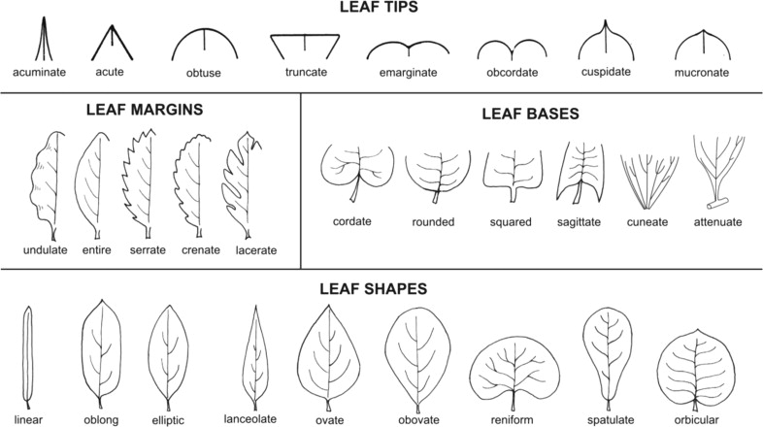

 | Leaf Tips | Leaf Bases | Leaf Margin | Leaf Shape | Bonus – Identification  Plant Name
Plant 1
Plant 2
Plant 3
Plant 4

Plant 5

Plant 6
Plant 7
Plant 8
Plant 9

Plant 10

